# Day 7 Assignment — Written Answers

Part A:
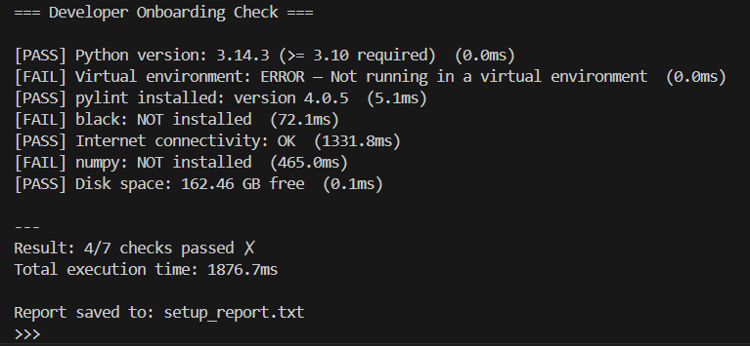

Part C: Interview Ready

Q1 — What is a Python Virtual Environment?

A Python virtual environment is an isolated folder on your computer that contains its own copy of the Python interpreter and its own set of installed packages, completely separate from your system-wide Python installation.

Developers use them so that each project can have its own dependencies at the exact versions it needs, without conflicting with other projects. For example, Project A might need `numpy==1.24` while Project B needs `numpy==2.0`; without virtual environments, only one version can be installed globally at a time.

What happens if you don't use one? Installing packages globally causes version conflicts over time — upgrading a library for one project can silently break another. You also lose reproducibility, because your environment will differ from your colleague's or your production server.

Real-world analogy: Think of a virtual environment like a separate toolbox for each job. A carpenter and an electrician may both own a screwdriver, but they keep their tools in separate boxes so they never accidentally use the wrong type or mix up each other's specialized equipment.

---

Q2 — Find and Fix 5 Issues

Original code:
```python
import os, sys, json
def checkVersion():
v = sys.version_info
if v.major >= 3 and v.minor>=11:
return "Good"
else:
return "Bad"

result = checkVersion()
temp = 42
print( "Version status:" , result )
```

The 5 issues:

1. Multiple imports on one line (`import os, sys, json`) — PEP 8 requires one import per line.
2. camelCase function name (`checkVersion`) — Python convention (PEP 8) requires `snake_case` for functions: `check_version`.
3. Missing spaces around comparison operator (`v.minor>=11`) — should be `v.minor >= 11`.
4. Unused variables (`temp = 42`, `os`, `json`) — Pylint penalises unused names; they should be removed.
5. Missing docstring on the function — Pylint requires docstrings for a score ≥ 8/10.

Corrected code:
```python
"""Module for checking the Python version."""

import sys

def check_version():
"""Return 'Good' if Python 3.11+, otherwise 'Bad'."""
version = sys.version_info
if version.major >= 3 and version.minor >= 11:
return "Good"
return "Bad"

result = check_version()
print("Version status:", result)
```

---

Q3 — ModuleNotFoundError for numpy

A junior developer installed numpy but Python still raises `ModuleNotFoundError: No module named 'numpy'`. Three possible causes and how to diagnose each:

Cause 1: Installed into the wrong Python (system vs virtual env)
The package was installed globally but the script is running inside a virtual environment (or vice versa).
```bash
which python # shows which python is active
pip show numpy # shows where numpy is installed
```

Cause 2: Virtual environment is not activated
The developer ran `pip install numpy` but forgot to activate the virtual environment first, so it installed system-wide while the script uses the venv's interpreter.
```bash
echo $VIRTUAL_ENV # empty means no venv is active
source onboarding_env/bin/activate # then re-install
```

Cause 3: Multiple Python versions on the system
`pip` belongs to Python 3.9 but `python` runs Python 3.11, so the installed package is invisible to the running interpreter.
```bash
python --version # check active version
pip --version # check which Python pip belongs to
python -m pip install numpy # always use this form to be safe
```

---

Part D: AI-Augmented Task

Exact Prompt Used

> "Generate a comprehensive `.pylintrc` configuration file tailored for a beginner-friendly AI/ML Python project. The project uses numpy, pandas, scikit-learn, and the standard library. Please include sections for MESSAGES CONTROL (disable rules too strict for beginners), FORMAT (line length matching Black at 88), DESIGN (relaxed thresholds), BASIC (allow common ML short names like X, y, df, lr), TYPECHECK (ignore dynamic numpy/pandas attributes), and SIMILARITIES. Add a comment on each disabled rule explaining why it is relaxed for beginners."

---

Critical Evaluation of AI-Generated `.pylintrc`

The AI-generated configuration showed a strong understanding of the overall structure of a `.pylintrc` file, correctly dividing it into `[MASTER]`, `[MESSAGES CONTROL]`, `[FORMAT]`, `[DESIGN]`, `[BASIC]`, and `[TYPECHECK]` sections. It correctly set `max-line-length=88` to match Black's default, which avoids constant line-length conflicts between the two tools — a genuine pain point for beginners.

However, a few choices needed adjustment. The AI disabled `W0611` (unused-import), which is actually a valuable learning signal for beginners; I re-enabled it with a comment explaining the trade-off. Similarly, it initially disabled `C0103` (invalid-name) globally without narrowing it to the `good-names` whitelist, which would allow genuinely bad names like single-letter variables outside ML contexts. I changed this to use `good-names=i,j,k,n,x,y,X,df,lr` instead.

The `[TYPECHECK]` section for ignoring dynamic numpy/pandas members was one of the most useful additions — without it, pylint raises false positives on `np.array`, `df.groupby`, etc., which frustrates beginners. The `ignored-classes` and `generated-members` entries fix this well.

Overall, the AI output was approximately 80% production-ready. The main gaps were over-disabling rules that would actually help beginners write cleaner code. A good practice is to treat the AI's output as a first draft that requires a code-review pass before committing.

